Topics for Paper #1 English 206/2, Fall 2007

Your first paper will be due Thursday, March 15, at the beginning of class. The late paper policy is stated on the syllabus.

Your paper must be double-spaced and at least five pages long. Great papers have been written that come in under the minimum length, but in most other cases size does matter.

There is no page limit, but if you go way over the minimum, you may find that editing it down enables you to improve the paper in other ways as well. Before you squeeze everything into a very small typeface, though, just leave it in the larger font. Think of your professor’s eyes. Needless to say, the use of excessively large fonts to extend a paper is a pretty transparent strategy.

Insofar as it suits your interests, you may bend but not break the paper topics. You don’t have to address ALL of the questions in the topic; they are intended as ways of encouraging you to form your own opinion.

Drafts are always welcome. Just give me a minimum of 48 hours to return them to you.

If you would like to talk your paper over with me, you should come to my office hours (TuTh 2:15-3:30, Fri 11-12 in Wheatley 06-091). If you can’t make those times, just make an appointment with me – my e-mail is leonard.vonmorze@umb.edu.
There is no one right path toward a good paper. Yet the single most important tip for getting started may be to think observation → analysis → argument as you review the readings in search of specific passages on which you can base your argument. Use your notes on your readings to generate observations. Look at the following example of annotations on a short passage:
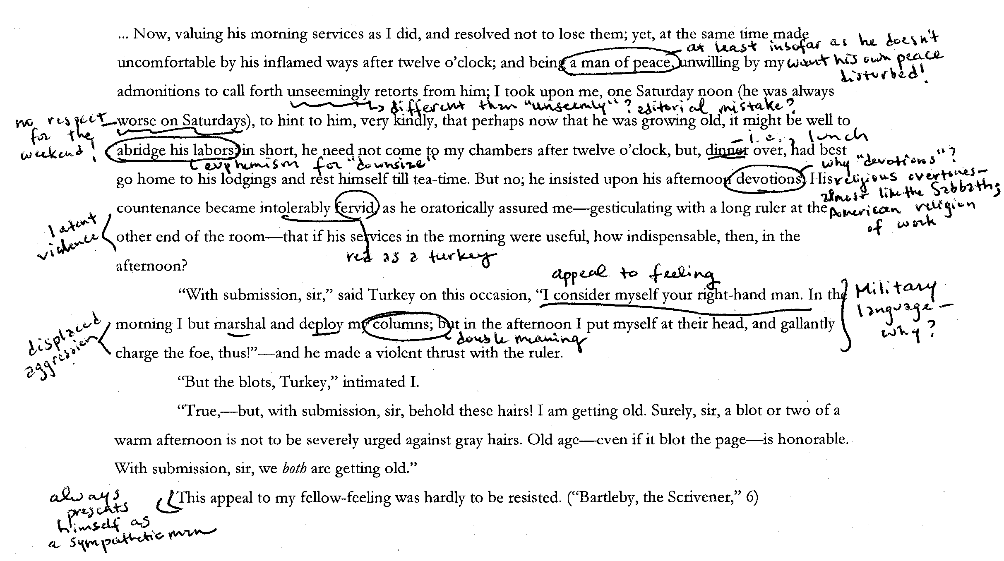
When making observations about a passage, the parts of the text that are difficult or perplex you can be deeply valuable. Try out some explanations of those difficult sections. Or trace the implications of figurative language (metaphors, similes, and metaphors), pay attention to the connotations of words (diction), or map out the system of values in a text, in which a good thing is implicitly yet consistently contrasted with a bad (patterns of opposition)? After you have collected a number of interesting observations that fit into some kind of larger pattern, analyze them. That means asking why the author might have chosen to write in this way, or how the form or medium in which they wrote may help to understand the author’s strategy in the passage you’re talking about. What effect is the writer attempting to create? Is there emotional manipulation, for example? For instance, the following two examples of analysis could be applied to the passage above:
The mock-heroic language which Turkey uses to describe his job, particularly his comically desperate use of an extended military metaphor in his speech, reflects the way that the scrivener might need to add spice to his mind-numbingly dull work.
Turkey successfully saves his job only by appealing to the narrator’s compassion or “fellow-feeling” while his appeal to reason fails.
At the stage of argument, you are essentially developing a thesis statement.
The three minor characters in “Bartleby” help Melville to establish the repressive nature of an early age of white-collar work at the beginning of the story.
The narrator in “Bartleby” paradoxically reasons that sympathy moves to action more effectively than reason. Ultimately, however, the tale reveals the limits of this faith in sympathy.
Other tips to keep in mind as you write:

1. Don’t worry about finding “right” answers: You are insightful and should trust your instincts, but you should test them against the text to make sure the text sustains your impressions. Whatever happens, you’ll have interesting things to say.
2. Think in terms of paragraphs: As you begin to plan this essay, think of it in terms of paragraphs, that is, points you want to make. Check to see if you have a unifying thesis. Anchor your understanding in the text of your poems or the novel: quote as needed, but remember that quotations are not self-explanatory. Your job is to comment on them so as to make your point, whatever it might be. Include page references for all quotations.
3. Have an argument about what you are discussing. There needs to be something that you are trying to prove; if there is not, there is no reason to write about it. Assume your reader knows the material but may not see it your way. Your goal is to convey your ideas to such a reader clearly, fully, and persuasively. Your authority will depend on how well you make your points, including quotations and other concrete references.

Three final requests: 1. Be sure to provide the number of the topic you are addressing. 2. Come up with a title for your essay. (Titles ideally have a “sexy” and a “substantive” part: they should draw the reader’s attention, but also give a strong indication of your argument.) 3. Remember that one of your two essays for this course should deal with more than one author. This requirement is intended to prepare you for the Writing Proficiency Requirement guidelines. When comparing authors, remember to ask what grounds there are for a useful comparison. That is, we know they are different, but what those differences reveal? What can we see by comparing them rather than by writing about each in isolation?
OK, here are the topics:

- Both Royall Tyler and Walt Whitman seem concerned with the problem of establishing an emergent American national identity. Some of the devices for securing the social compact we considered in both writers included the use of romantic courtship and passion as a national allegory of how Americans came together into one union. Another device was the use of a distinctively American vernacular. And, finally, both writers had to carve out a sense of authorship defined by its relevance to a new reading public. How do Tyler and Whitman establish American national identity? You can examine one of the three ideas just suggested, or invent your own. Where and how in their works is social unity established? Are there also moments in which social boundaries are transgressed? What larger “One” does Whitman, for instance, wish to create from the “Many” he speaks of? How do Tyler and Whitman relate to their American audience (Tyler’s prologue, or Whitman’s address to the “you”)? (Where and how does the “I” of Whitman’s poem speak of merging with the “you”?)
- A variation on topic #1 would be to focus on American writing about the Civil War instead of the early American republic. How does Whitman’s thinking about national unity change during the Civil War? Can you make comparisons between the poems “Walt Whitman” and “The Wound-Dresser,” for instance? Is the meaning of sympathy (i.e., the ability to exchange positions with another) the same in his pre-Civil War and Civil War poems? What connections can be drawn between Whitman’s and Melville’s representations of the war? How do Whitman and Melville acknowledge, explain, or sympathize with the forces of disunity?
- The distinction between the public and private spheres was an influential way of defining gender experience through the nineteenth and much of the twentieth centuries, because women were generally forced to adhere to rigidly defined “functions” in the home while men moved throughout both public and private society (but were also thought to belong in the public realm of business). Emily Dickinson’s poems and letters defy (but also sometimes celebrate) women’s association with the private realm, while Melville’s Bartleby reflects the extreme of male experience in the workplace. Do the private and public appear to have a gender in Dickinson and Melville’s work? Where are men and women most “free”? What are the issues at stake in Dickinson’s representation of marriage and Melville’s representation of bachelorhood? Are there are continuities between the two writers as well as differences? What alternatives does Dickinson find to the values associated with marriage, and what ethic does Melville oppose to the ethic of Wall Street (though, for instance, the New Testament echoes in the story)?
- The elegy (a poem mourning a death) has a long history in American literature. As mentioned in class, the majority of Wheatley’s poems are elegies (for instance, “On the Death of Rev. Mr. George Whitefield”; note also the ending of “To…the Earl of Dartmouth”), and most of the Civil War poems we are reading by Whitman (“When Lilacs Last in the Dooryard Bloom’d” as well as several shorter poems in Connaroe) as well as those by Dickinson qualify as elegies. Choose a couple of elegies, and then use the following questions as starting points for your reflections: What do you think is the aim of the elegies? What difference does the object of the elegy—for example, a public versus a private figure—make for the content of the poems? Does mourning the dead allow the poet to work through his or her feelings, or does the poem leave some of those feelings unresolved?
- The meaning and significance of “race” was hotly contested in American literature before the Civil War. Analyze the representation of race in one or two of our texts (the clearest examples would be Wheatley’s poems or Melville’s Benito Cereno). Do these writers seem to think that racial difference is only “skin deep” or does it have a greater meaning in their work? How does the issue of imitation complicate our understanding of racial difference? For example, how do(es) Wheatley and/or Melville play with images of whiteness and blackness? Can Babo’s masquerade shed light on Wheatley’s rhetorical humility?

